Once upon a time, in a small town called SQLville, there was a renowned bookstore named "Books & Bytes." The store had a vast collection of books, ranging from classic literature to modern technology.

As part of their college curriculum, the students of SQLville University were tasked with learning the basics of MySQL and database management. To make the learning experience more interactive and practical, the bookstore decided to collaborate with the university and create a hands-on assignment for the students.

**Assignment:**

You are a student studying computer science at SQLville University, and you have recently started your journey into the world of databases and SQL. The assignment given to you by "Books & Bytes" is as follows:

Create a database named "BooksDB" to store information about the bookstore's collection of books.

Design a table called "Books" to store the details of each book, including the book's title, author, genre, publication year, and price.

Insert at least five books into the "Books" table, ensuring that each book has unique information for all columns.

Write SQL queries to perform the following tasks:

a. Retrieve all the books from the database.

b. Retrieve the details of a book based on its title.

c. Update the price of a book.

d. Delete a book from the database based on its title.

Your task is to complete the assignment by writing the required SQL queries and demonstrating your understanding of basic MySQL concepts.

Good luck with your assignment, and may your SQL skills shine brightly in the realm of databases

**CODE:**

**a.Retrieve all the books from the database:**

CREATE DATABASE BookDB;

USE BookDB;

CREATE TABLE Books (

Title VARCHAR(50),

Author VARCHAR(30),

Genre VARCHAR(20),

Publish_Year INT,

Price DECIMAL(5,2)

);

DESCRIBE Books;

INSERT INTO Books VALUES("Dog Man","Dav Pilkey","Comic",2016,65.00);

INSERT INTO Books VALUES("Dune","Frank herbeRT","Sci-Fic",1965,200.00);

INSERT INTO Books VALUES("Educated","Tara Westover","Non-Fiction",2018,250.00);

INSERT INTO Books VALUES("Jane Eyre","Charlotte Bronte","Novel",1847,300.00);

INSERT INTO Books VALUES("Into Thin Air","Truman Capote","Narrative",1997,90.00);

INSERT INTO Books VALUES("Gilliyan Flynn","Gone Girl","Mystery",2012,97.96);

SELECT * FROM Books;

**Output:**

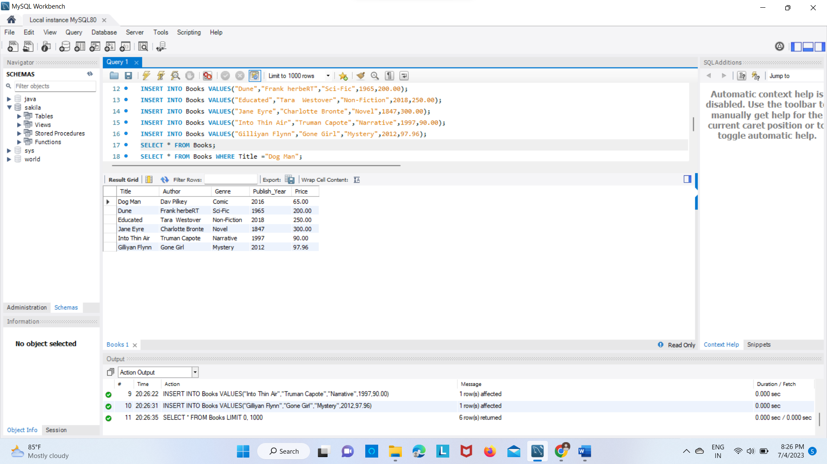

**b. Retrieve the details of a book based on its title.**

SELECT * FROM Books WHERE Title ="Dog Man";

**Output:**

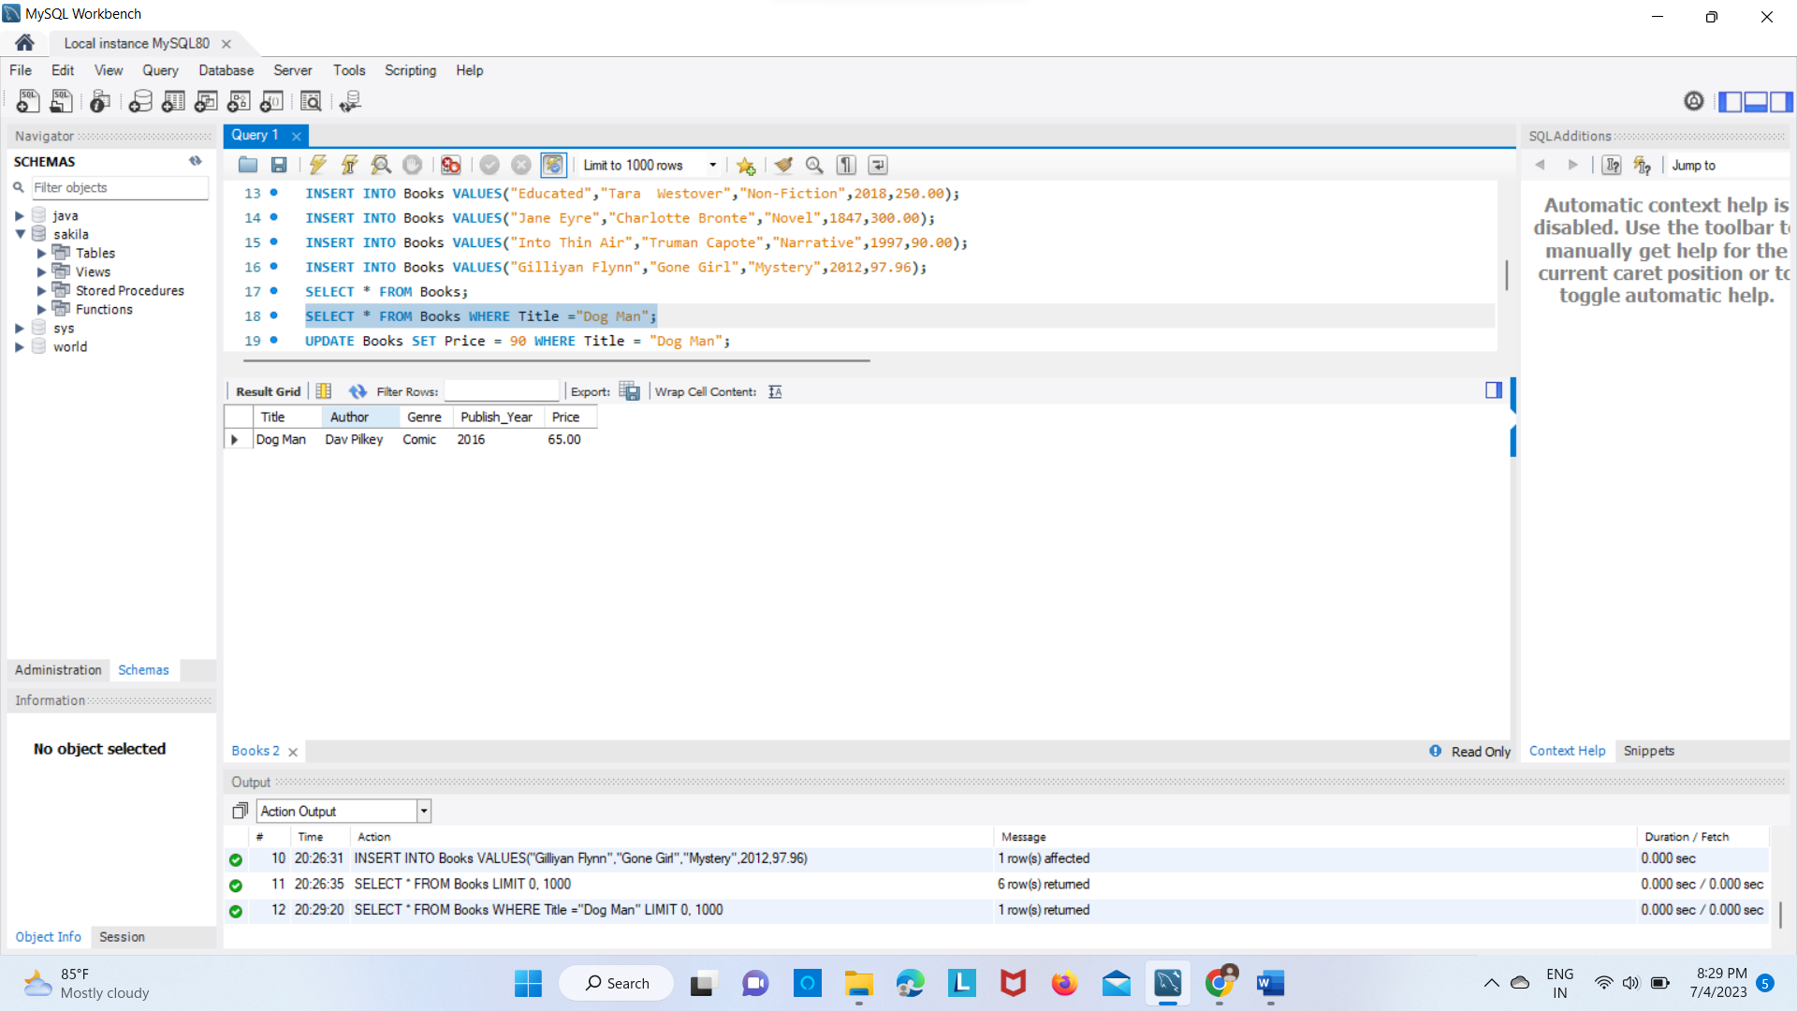

**c.Update the price of a book.**

UPDATE Books SET Price = 90 WHERE Title = "Dog Man";

SELECT * FROM Books;

**Output:**

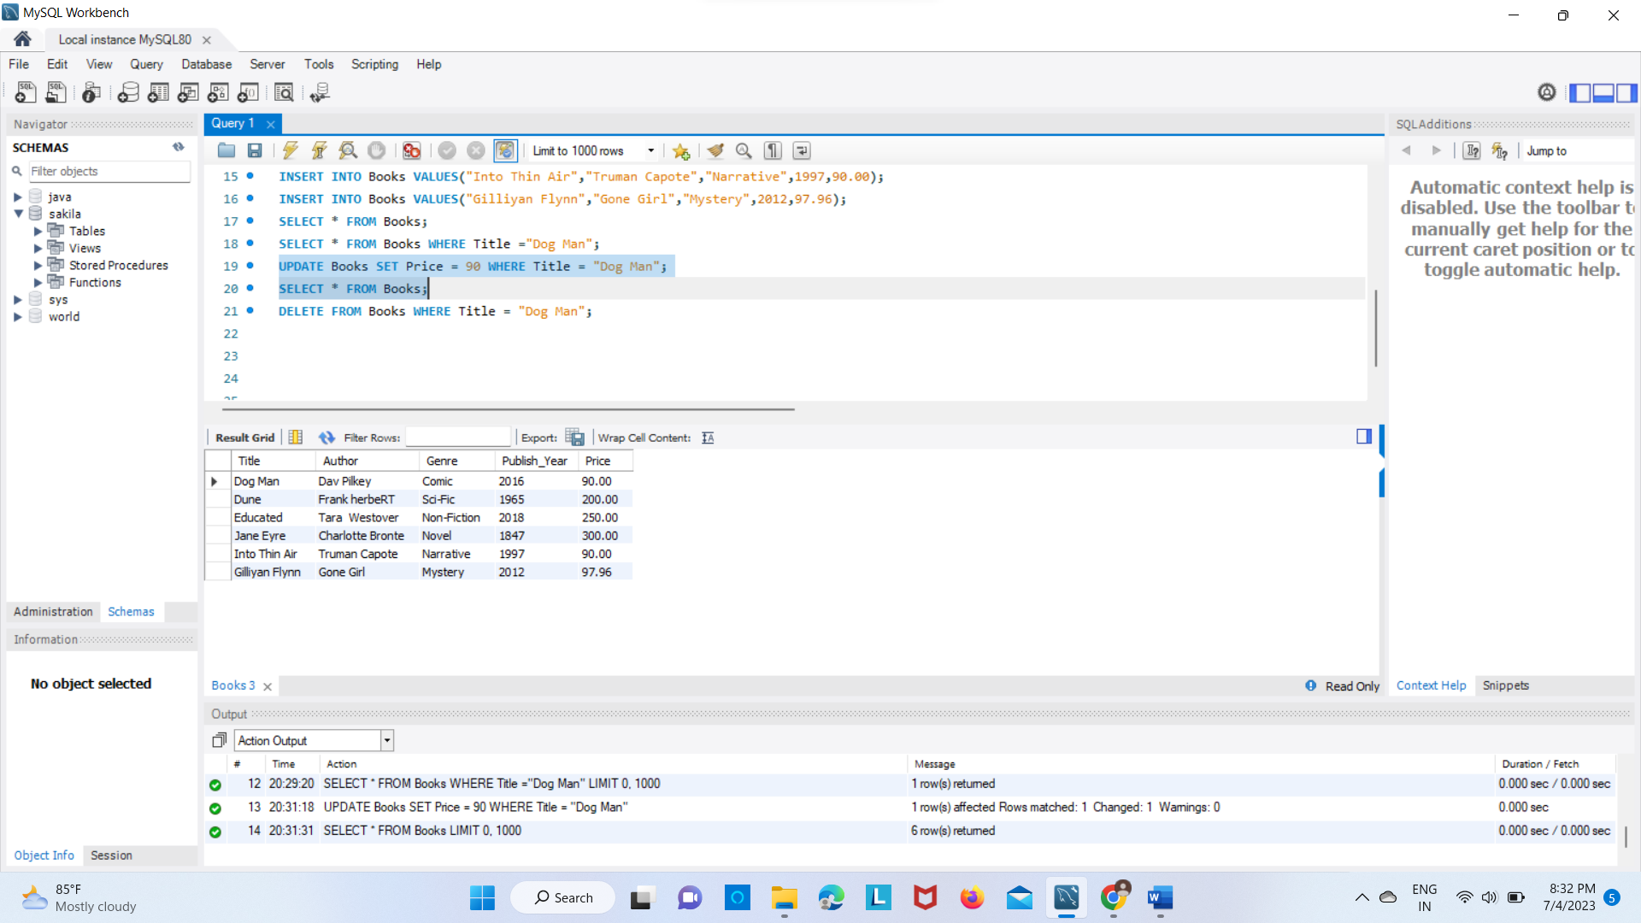

**d. Delete a book from the database based on its title.**

DELETE FROM Books WHERE Title = "Dog Man";

SELECT * FROM Books;

**Output:**

